**DTCC Toner Inventory System User Guide**



**Team Coffee House**

April 20th, 2019

**Team Members:**

David Clendenning

Logan Yoder

John Ryan

Jon Lewis

**Contents**

Contents…………………………………………………………………………………………………………………………………2

1 Introduction…………………………………………………………………………………………………………………………..3

2 Quick Start Guide…………………………………………………………………………………………………………………..3

3 System Requirements…….………………………………………………………………………………………………………5

4 Main Scenarios of Use……………………………………………………………………………………………………………5

5 Troubleshooting……….……………………………………………………………………………………………………………6

**1 Introduction**

The DTCC Toner Inventory System application allows users a simple interface to access and interact with their toner inventory from a local terminal. This document will provide instructions for using the application to view printers and their respective compatible toners, add and remove toners from the database, and export the data to a local tangible report.

**2 Quick Start Guide**

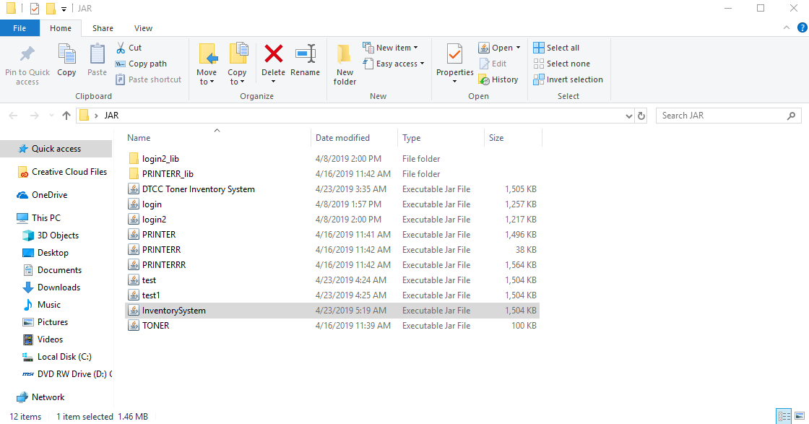

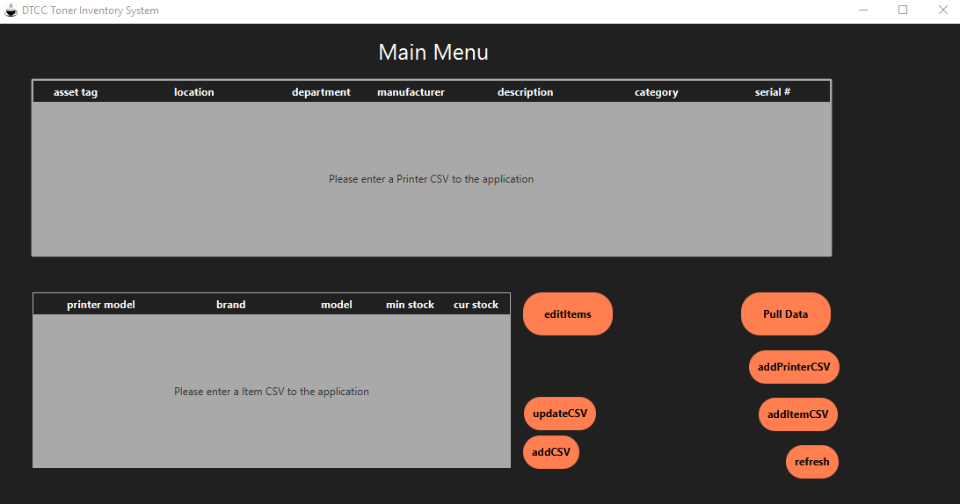

1. Locate and double click the “InventorySystem” file located within your system. The main menu will be brought up.
2. Current options to access toner inventory will be brought up.

**3 System Requirements**

The DTCC Toner Inventory System should be installed on a Windows 10 based terminal. Refer to the System Documentation for instructions on installation.

**4 Main Scenarios of Use**

***4.1 Edit Items***

***4.1.1 Add***

1. Double click the editItems button located in the middle of the main menu. This will bring up a new window to edit items.

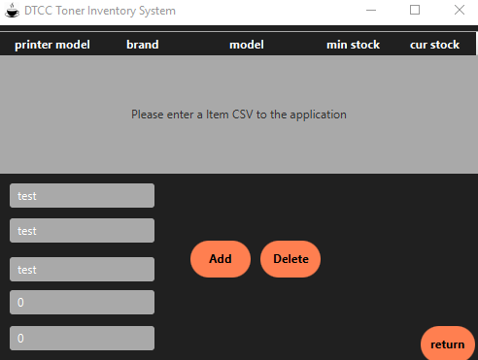

2. Enter data of item into the specified fields “Printer Model”, “Brand”, “Model”, “Min Stock”, “Cur Stock”.

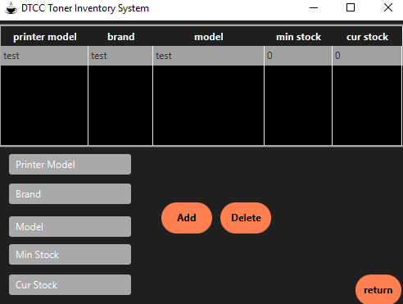

3. Double click the “Add” button; this will add the item entered into the table above.

4. Double click the “Return” button, this will return you to the main view from the previous steps.

***4.1.2 Delete***



1. Hover over the selected record that you wish to delete.

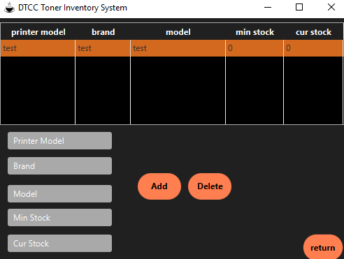

2. Click the selected record; this will shade the specified record an orange tint.

3. Double click the remove button.

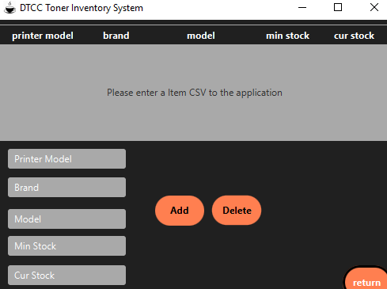

4. Double click the “return” button to return to the main menu.

**4.2 CSV Entry**

**4.2.1 Manual**

1. Navigate to the main menu of the program.

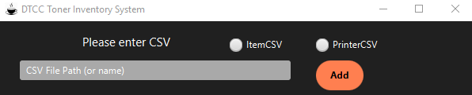

2. Double click the “addCSV” button; this will pop up a manual entry for a CSV.

3. Enter your CSV file path

4. Click one of the two buttons at the top right of the window to the corresponding CSV file type you wish to enter (Printer/Item(Toner)).

5. Double click the “Add” button; you now have added your CSV to the program.

NOTE: The buttons can both be clicked at the same time but this will result in the CSV file entered being ignored due to the fact that the program cannot determine what it is.

**4.2.2 Choosing File**

1. Navigate to the main menu of the program

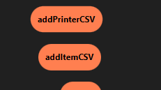

2. Double click the “addPrinterCSV” or the “addItemCSV” depending on your CSV file type (printer/item(toner)).

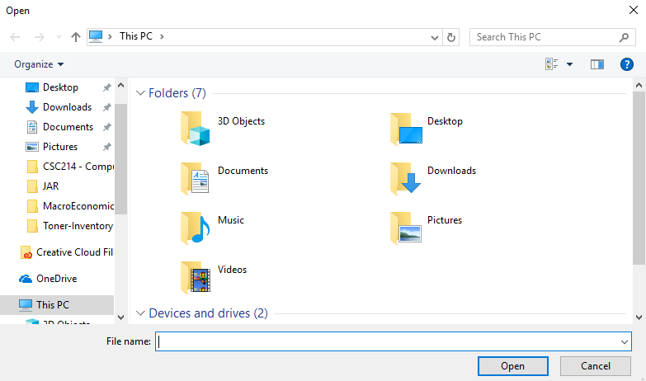

3. A system window will pop up and allow you to navigate through the computers directory and select a file.

4. Navigate to your particular CSV file, hover your mouse over it, and double click your mouse; this will allow the file to be automatically opened.

5. The program now has the selected CSV file(s) within its system and is ready to have the data extracted

**4.3 Input/Output (to/from CSV(s))**

**4.3.1 Input**

1. Navigate to the main menu of the program.

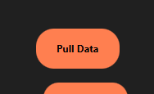

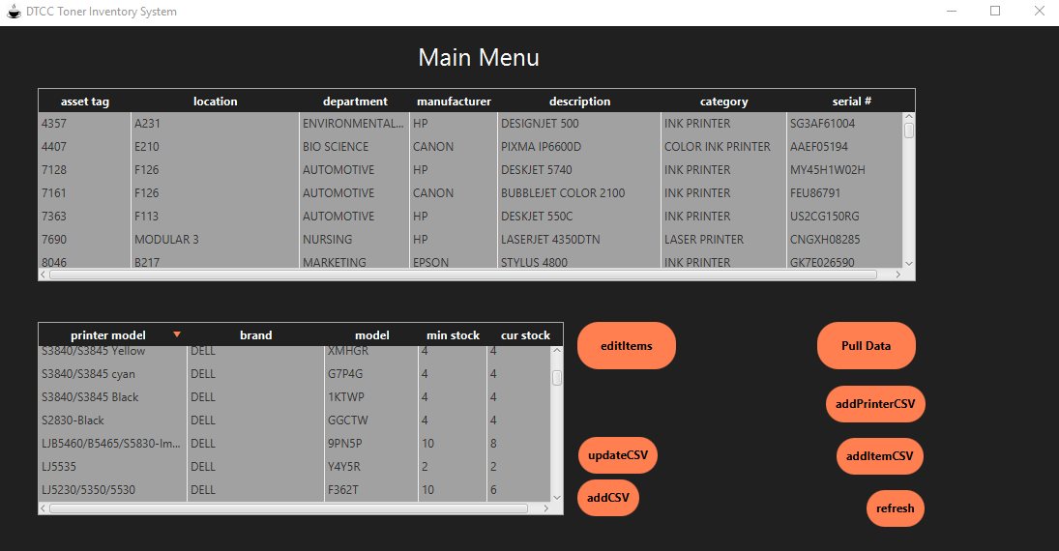

2. Double click the “Pull Data” button in the right-center section of the window; this will pull all of the data within the CSV file(s) and populate the tables at the top / bottom-left of the screen. (*This is under the assumption that you have completed step 4.2 and have successfully stored your CSV files*).

**4.3.2 Output**

1. Navigate to the main menu of the program.



2. Double click the “updateCSV” button at the bottom-center section of the window; this will update (append) the CSV in the program with the data that you have added/removed within the “editItems” menu discussed in section 4.1.

**BEFORE:** 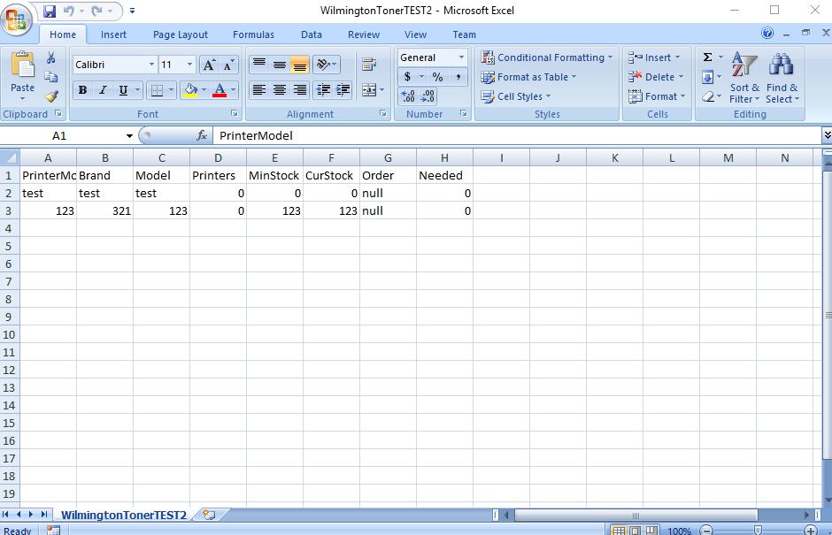 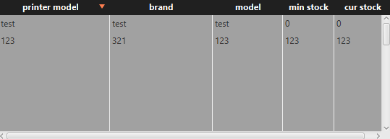

**AFTER:**

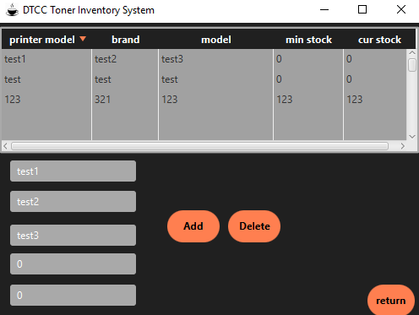 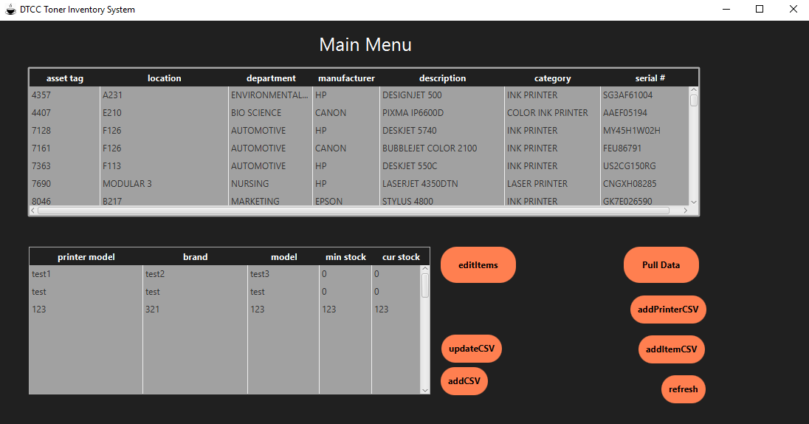 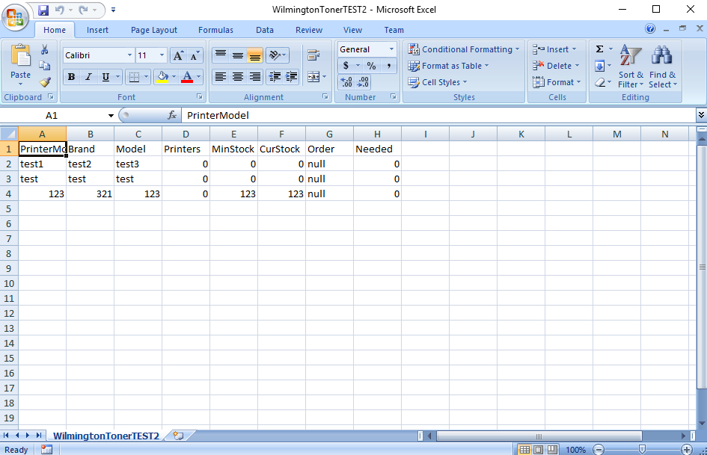

**5. Troubleshooting**

***5.1 Missing or incorrect data in tables***

ENTER ERROR MESSAGE HERE?